Student Activity
29 Internal resistance of a dry cell

TASK
To measure the internal resistance of a fresh and a flat dry-cell battery.

THEORY
Any device that generates an EMF (such as battery, generator, or solar cell) offers resistance to the passage of electric charge through itself. This resistance is called the internal resistance of the device. For any device:
V = ε – Ir
where ε is the EMF of the battery and r is the internal resistance in ohms.

EQUIPMENT
• dry-cell batteries; fresh, flat, and different types (alkaline, heavy duty, etc.)
• DC voltmeter (0–10 V) or voltage sensor
• DC ammeter (0–1 A) or current sensor
• rheostat
• switch
• connecting wires

ICT
Most current sensors have a 1 A range and are suitable for this experiment.
They are generally current-protected, but take care to check the manufacturer’s specifications, and use sensors with care.
Exceeding the maximum current rating will permanently damage an ammeter or sensor.
Sample rate: Sample voltage and current manually for each setting of the rheostat.
Use a digital display to view and record instantaneous values.
Graph: V against I and use your gradient tool, curve fitting or similar to determine the internal resistance from the gradient of the graph.

NOTES ON METHOD
1. Connect the circuit as shown in the diagram.
Adjust the variable resistor until the current through the ammeter is about 0.1 A to 0.2 A, and read both meters.

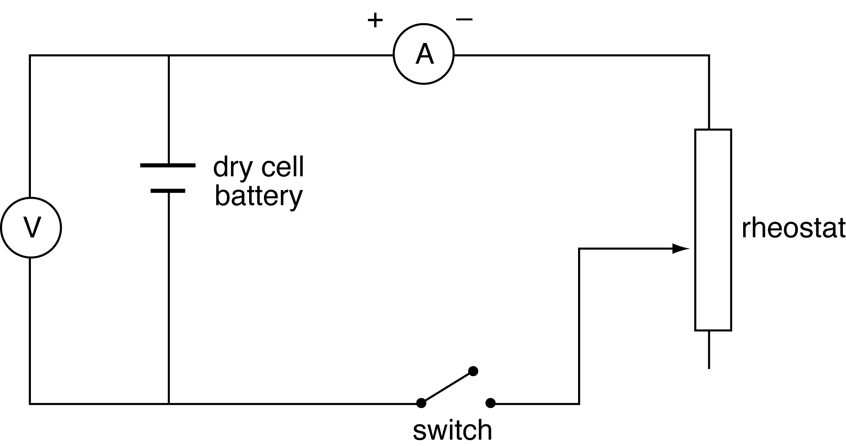
2. Alter the variable resistor through about four or five positions over its full range of values and obtain a set of corresponding readings of current I and potential difference V between the battery terminals.

3. Draw a graph of V against I and use it to find the internal resistance of the battery.

DATA & ANALYSIS
Construct a table of corresponding values of V and I.

Draw a graph of V against I using your values.

From the graph, determine the value of the internal resistance of the battery and its EMF.
continued
29 Internal resistance of a dry cell

CONCLUSION
Based on your results, how does the EMF and internal resistance of a flat dry cell compare with that of a fresh dry cell?
How does the internal resistance of an alkaline battery compare with that of a heavy duty battery?

QUESTIONS
1. The batteries in a radio have been used for a long time. Explain why the volume of the radio is low even though the EMF of the batteries is the same as when they were first bought.
2. Does a power pack have internal resistance? If so, what do you think causes it?

